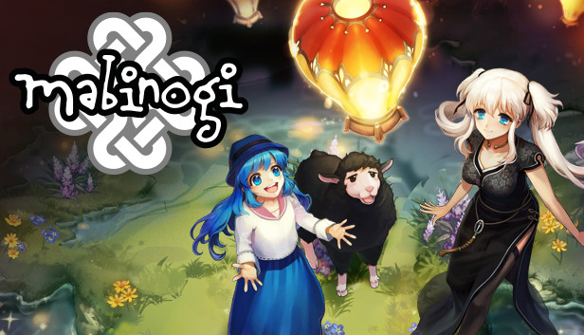

About This Game:

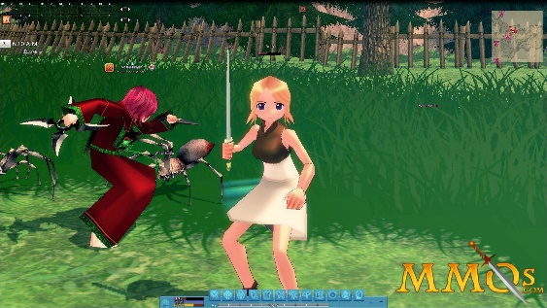

**The world's most expressive MMORPG, where you create a unique character and live your fantasy life**. Enter the mystical land of Erin, where a century-old battle threatens the balance of the known world. Explore exotic locales, defeat mighty foes, and follow the path to destiny.

Mabinogi is a massively multiplayer online role-playing game released by Nexon and developed by dev studio. The name of the game is taken from the Welsh word Mabinogi, a Welsh anthology of legend, and the settings for the game are loosely based on Welsh mythology. [Wikipedia](https://en.wikipedia.org/wiki/Mabinogi_(video_game))

**Developers:**[Nexon](https://www.google.com/search?bih=730&biw=1517&rlz=1C1UEAD_enPK1023PK1023&hl=en-US&q=Nexon&si=AEcPFx7HnMxbNS2egwqbd2fGseeWkZi3ZCVlQ3vY-NLoLE7SWY2TSBgmXrm6MsqUMyhE1AiAgbNwRSBSI1s9A0fXTookhIgfGAlEdGPTyP77Mk0O6wM29BebEF_GnOZSPSH8iaJIIRNeWWzbON-_3-Y5AFKN3Ad9jLCCXNyL75HnqKzr8o_5NTVgtaWNDZmT6MYL3w-ZoWe3VHhzgYD_Q3HzmzLp6cTtpRgFXaBQCZ_m7l-BOWiZ4ipDjQwoNCK3w1XEMz-bUWrqJmyVcPGI3Yeu8EtF1mgk0A%3D%3D&sa=X&ved=2ahUKEwje3N2-s_P8AhU7ZaQEHUo6A6YQmxMoAHoECHIQAg), [dev CAT studio](https://www.google.com/search?bih=730&biw=1517&rlz=1C1UEAD_enPK1023PK1023&hl=en-US&q=devCAT+studio&si=AEcPFx6JXutHkM717ja3aO41YP5w59cvuIQ168G5lhV1D2WrybGQUoWE0bT6x5AkdaEGgx2VOj1i49bASXHK0ViBbuHZ8gZrXiXAX0Q27UZHUsuybxQal5lsgY8pMGGZfvbHpC7o5FUcjiFP2mYiaR9RzQbNAh8ufeB7Wmf_gEt8SZLyqgyR-AWo0q9kHiGAAW86-HEbtYiUTisY5NaobL8e8nJYw4lkmLIhQJuzn5KUSigj3HBC4tOxRDl6n9Gz95DevigrCy4-ewl7f09REVkVqSk-u5Zi4w%3D%3D&sa=X&ved=2ahUKEwje3N2-s_P8AhU7ZaQEHUo6A6YQmxMoAXoECHIQAw), [NEXON Korea](https://www.google.com/search?bih=730&biw=1517&rlz=1C1UEAD_enPK1023PK1023&hl=en-US&q=NEXON+Korea+Corporation&si=AEcPFx4IkMgAgMJkMTLSH7WR6YtBj6EFtw5Le3AcsuhiKcMgwiN_Msp8EQ1uxtox49Sv_MuhjQoym7wrTzx78oLw63pBxeQDb2dJT7I34FYs02QWDaCK9YBsoCKk8Dhl3UwmxKC1yrGji7uZSU8qiFD9hVKqbmJgdVBnu2dRnW-vliHVTiCS4RkS2gdu5_oKW3dmetE5WyrNxBgtthIuyAujLat7xzp794ho5OQ1nd4VevORSpAhXkTBYwhIgP5F5T2Arq1i36VJ_F4kM4B3u7VVe-468foQi2QqpG1BK6yKuAezPTHDWUY%3D&sa=X&ved=2ahUKEwje3N2-s_P8AhU7ZaQEHUo6A6YQmxMoAnoECHIQBA)

**Engine:**[Source](https://www.google.com/search?bih=730&biw=1517&rlz=1C1UEAD_enPK1023PK1023&hl=en-US&q=Source+(game+engine)&si=AEcPFx5y3cpWB8t3QIlw940Bbgd-HLN-aNYSTraERzz0WyAsdBpQ-Cly0Th0uSBqjarIE5mdejvueoUoBybfW_2uUdYTYkUEHPJGcT2mz2jcFPiWBT0uYoSUVUIPvJ9uJo1TzrDmBpuZHoPt0c3nHz9GVUHqyTBIq4Culo34bii6J87U-RL090nNJ0etRgPO68Xfl0RFemmchN7xGJsPWPtw8anp2bJC1g%3D%3D&sa=X&ved=2ahUKEwje3N2-s_P8AhU7ZaQEHUo6A6YQmxMoAHoECGQQAg)

**Initial release date:**June 22, 2004

**Platform:**[Microsoft Windows](https://www.google.com/search?bih=730&biw=1517&rlz=1C1UEAD_enPK1023PK1023&hl=en-US&q=&si=AEcPFx6l3RvH8SFlhHZyn7jIc6m2bU9vmoFvFAMQv2WWSYjXNyS67HqH0UuOxKt1cReYTH1BLJGCaDY830FOsYxSJ63CvhLojm6BkYAD4P09kuvRgtozStExA7jAOWInTAo5lQDedwAvLQs-pLEpd6WHi4rg-agWVKk3mo41Dr4wyVKTj1EBCoU%3D&sa=X&ved=2ahUKEwje3N2-s_P8AhU7ZaQEHUo6A6YQmxMoAHoECF8QAg)

**Publishers:**[Nexon](https://www.google.com/search?bih=730&biw=1517&rlz=1C1UEAD_enPK1023PK1023&hl=en-US&q=Nexon&si=AEcPFx7HnMxbNS2egwqbd2fGseeWkZi3ZCVlQ3vY-NLoLE7SWY2TSBgmXrm6MsqUMyhE1AiXzkUr1LqRRvBp8JUCeNCzcanRFdCnfpcGg6ADuGuuhRWuFKac7WtT513l6OdUhY1YmK7tBCD6bf81mxmdWsrt1b1pTmycZ66_P7kTuhX82vMS67erJIzwWlb9RS-Cz2GjZ0KSU056Hf6gItP8dWSiEYwdhSC0rSYl-Du2E0LgryjXv8WoHopYK4JBMOxlQ1yrX2J2&sa=X&ved=2ahUKEwje3N2-s_P8AhU7ZaQEHUo6A6YQmxMoAHoECGIQAg), [Gamania Digital](https://www.google.com/search?bih=730&biw=1517&rlz=1C1UEAD_enPK1023PK1023&hl=en-US&q=Gamania&si=AEcPFx5y3cpWB8t3QIlw940Bbgd-HLN-aNYSTraERzz0WyAsdDuza9rlhFS87cb5sW-4XBKTdjIhrfAMac_aSTa-Q9r5JdNcFK2X4cr8vPGg5LTeMBmv6U-FPiHtcyK1GsUm5c2Mrl3JFy5_CiygiJ4KMrr8323kvnLD_bykj8_TiVNJUgaj2c6H7iBeR_tqN7uAZH7qR-W_hideVit0ltilXxn6HSAwnsn5f2RY2MyqM49uOPY1fVC4gLfKNpTjh59005H2hfZH&sa=X&ved=2ahUKEwje3N2-s_P8AhU7ZaQEHUo6A6YQmxMoAXoECGIQAw), [Nexon America Inc.](https://www.google.com/search?bih=730&biw=1517&rlz=1C1UEAD_enPK1023PK1023&hl=en-US&q=Nexon+America+Inc.&si=AEcPFx7eHRJU0tWbjC5cc2C2rVygfPuoetC2JDc0IDqLp89f-BZdMJxPDgqRGFAUG00QMvIubBWtpucsaNg9Js12yKnK-gcMLHdE1q736EDr08LHtgCc1dZzfM2nDL4gTdNq1cHfEOC0szofEJYcl-2Szsf6nQk4kzSOsmyCW5ncxbWWA36yzQ3498JAoi1l0rILYDvL3XFdxrc_0ZCCO7u-Ow3MmhqqCIhb16YaB71URb1DPZheU3BZMuse-mEjbFrMHaM2PbFjqm0Fm3FNWIc39m4fICKEJA%3D%3D&sa=X&ved=2ahUKEwje3N2-s_P8AhU7ZaQEHUo6A6YQmxMoAnoECGIQBA)

**Genres:**[Massively multiplayer online role-playing game](https://www.google.com/search?bih=730&biw=1517&rlz=1C1UEAD_enPK1023PK1023&hl=en-US&q=&si=AEcPFx6l3RvH8SFlhHZyn7jIc6m2bU9vmoFvFAMQv2WWSYjXN2POjrc0dzMxvj0XE9iWXVH_ZcMHmkFXHagWziDVzmBf397dmo3hootmLwyr4ygVpqiK1CWkPKRQzepegWdtFvFaMjBbevRxYMy_w5NDhfNBIJWdO5ipfef02Bct0Cv6YSbFNjAyzf-0WM-3ePYk6zwN2n0OBdkkCnUlLuFMGycaugcbs7avaBQOuPAXImQRbExbhQRF-zKZpt_z72WCUAiFiV-c&sa=X&ved=2ahUKEwje3N2-s_P8AhU7ZaQEHUo6A6YQmxMoAHoECGYQAg), [MORE](https://www.google.com/search?bih=730&biw=1517&rlz=1C1UEAD_enPK1023PK1023&hl=en-US&q=mabinogi+genres&stick=H4sIAAAAAAAAAOPgE-LUz9U3ME9PM6nSUslOttJPLkvXT87PLSgtSS2KL8tMSc1PT8xNtQIKx6en5hWlLmLlz01MyszLT89UAAsUAwAoAOaDRQAAAA&sa=X&ved=2ahUKEwje3N2-s_P8AhU7ZaQEHUo6A6YQ44YBKAF6BAhmEAM)

**Mode:**[Multiplayer video game](https://www.google.com/search?bih=730&biw=1517&rlz=1C1UEAD_enPK1023PK1023&hl=en-US&q=Multiplayer+video+game&si=AEcPFx5y3cpWB8t3QIlw940Bbgd-HLN-aNYSTraERzz0WyAsdEYnzlnfjzOkOOGzw7gnFGl7_j2ueQkDQwSGNgJhUbsLZC6MYQO_eLQR6wam6w8mtkH9wr_Btc4nlkMbsGyd8XIP1YXBCTAyeX4PnP5QbyD-9_RJDAzno0OVE4gLLspGMxmPStYGYzUXlb7xChrP6mimeL6usUKa-9cAj_QXyEdVf8x4Cg%3D%3D&sa=X&ved=2ahUKEwje3N2-s_P8AhU7ZaQEHUo6A6YQmxMoAHoECGMQAg)